Regional Rail Investment Decision-making Framework

BACKGROUND
As part of the Triangle Rail Study co-sponsored by the Capital Area Metropolitan Planning Organization (CAMPO) and the Triangle West Transportation Planning Organization (TWTPO), the MPOs are seeking a framework for how to prioritize and invest in rail-related projects that may be physically in one location or jurisdiction but provide benefits to intercity passenger rail expansion in multiple jurisdictions.
This memo proposes a series of principles as the decision-making framework that local policymakers should use to account for the opportunities and constraints that the Triangle region faces in building an intercity passenger rail network.
PRINCIPLE ONE: UNDERSTAND THE FRA WORLDVIEW
While the Triangle region has significant familiarity pursuing rail and Bus Rapid Transit projects with the Federal Transit Administration (FTA), any incremental intercity passenger rail improvement is likely to be delivered under Federal Railroad Administration (FRA) rules and regulations. FRA prioritizes and emphasizes:
- Connections BETWEEN different metropolitan areas, not connections WITHIN one metropolitan area (the latter is typically commuter rail under FTA oversight).
- Connections of new or expanded intercity passenger rail to other parts of the national intercity passenger rail network.
- Preparedness and coordination among stakeholders are key; ridership projections are of lower importance than with FTA.
PRINCIPLE TWO: UNDERSTAND FREIGHT RAIL OPERATOR WORLDVIEW
Norfolk Southern (NS) and Chessie System and Seaboard System (CSX) are major players and dispatchers of rail traffic in the Triangle region and statewide. Other smaller owner-operators are present, and the views of how much passenger rail development is beneficial may vary. This study’s Technical Steering Committee (TSC) meetings have highlighted:
- Corridors where a freight railroad and the public sector already have a passenger rail operating agreement are inherently easier to work on service expansion than a corridor where no passenger rail operating agreement exists.
- There is acceptance on the part of NS that the NC-line between Raleigh and Greensboro needs capital improvements for both freight and passenger rail.
- The line from Fayetteville to Fuquay-Varina was purchased by RJ Corman Railroad Group in 2022, while leasing the 20 miles from Fuquay Varina to Raleigh from NS, and they are very interested in passenger rail from Raleigh to Fayetteville.
PRINCIPLE THREE: UNDERSTAND NCDOT RAIL OBJECTIVES
The NCDOT Rail Division has been among the most successful state DOT rail programs in the USA for the past two decades, securing $545 million in 2008-2009 to build out the Piedmont Improvement Program between Raleigh and Charlotte, and $1 billion of federal investment in 2024 to extend the Piedmont service to Wake Forest as part of the buildout of the Southeast High Speed Rail corridor. In this study, NCDOT Rail has shared:
- That potential Service Development Plans of rail projects on lines without Corridor ID grants from FRA are functionally 2 years behind lines WITH Corridor ID grants. For example, service to Sanford would take 2 years longer than service to Clayton because Clayton is in the Raleigh to Wilmington Corridor ID grant.
  - Mebane to Franklinton would be a top priority for NCDOT since they have an operating agreement with NS for Mebane to Raleigh and they will own the S-Line to Franklinton.
  - A second priority would be Raleigh to Fayetteville due to cooperative rail line owner as mentioned above.
  - Investment towards Clayton/Selma would likely be third.
- They see a benefit in investing in doubletracking projects for sections of rail from Mebane to Raleigh as it will create momentum to build out projects for service concepts that overlap with this corridor
- NCDOT has identified that their Corridor ID service from Winston-Salem to Raleigh could go on to Wilmington
- That projects within NC that connect urban and rural areas resonate with the NC General Assembly
PRINCIPLE FOUR: UNDERSTAND HOW THE NCDOT SPOT PROCESS SCORES RAIL PROJECTS
The primary method for receiving state funds for rail projects is the NCDOT Strategic Transportation Prioritization (SPOT) process. While there are several Specific Improvement Types (SIT codes) for rail projects, intercity passenger rail-focused projects may only be funded at the Regional Impact and Division Needs Tiers of funding, while freight rail investments may also be prioritized at the Statewide Mobility Tier. In this study, the project team has learned:
- The current SPOT Rail Mode scoring methodology process tends to reward investing in EXISTING passenger rail corridors over developing new track and services outside of current routes.
- Safety projects, particularly grade separations, score well for state funds. Those grade separations that also close two or more at-grade crossings are more likely to win concurrent support from freight railroads.
- Putting local money into building rail stations ahead of track improvements may make it easier to get funds for track improvements later. Intercity passenger stations within 16 miles of other stations are more likely to cannibalize existing station ridership in models than primarily add new ridership.

PRINCIPLE FIVE: UNDERSTAND RELATIVE FEDERAL FUNDING VIABILITY
This study was conducted between October of 2024 and June 2025, a timeframe which spanned the transition from the Biden administration to the second Trump administration and reflected a period of policy dynamism and significant change in public policy across many federal agencies.
The Trump Administration has eliminated secondary grant award criteria previously adopted by the Biden Administration. It is possible that Congress could make statutory changes to grant programs, particularly as part of a transportation reauthorization bill to replace the IIJA when it expires on Sept. 30, 2026. Any statutory changes enacted by Congress could have a substantial impact on programs, including program definitions and eligibility and merit criteria applied to award grants.
The new administration under Transportation Secretary Sean Duffy did not release any Notice Of Funding Opportunity (NOFO) grant announcements during the first six months of 2025.
Therefore, for the federal funding screening, the project team evaluated projects against existing federal award criteria based on the statutory requirements for each grant program.
Using this approach and based on the Service Concepts identified in Figure 1, the project team believes that corridors which have existing (Amtrak Carolinian, Piedmont, & Floridian services) or planned (S-Line to Wake Forest) service are most likely to attract Federal funding in the near term.
This means that among the Service Concepts studied, Mebane to Clayton is the most likely to be attractive to Federal criteria, followed in order by:
- The Raleigh to Wake Forest and Franklinton (S-line) section of Sanford to Franklinton
- The Cary to Apex and Sanford, section of Sanford to Franklinton, given lighter existing and future passenger rail traffic in this corridor
- Durham to Raleigh (lower priority because these investments are discretionary enhancements to the improvements in Mebane to Clayton, and because of the shorter distance covered by the service)
- Lillington to Raleigh
- Carrboro to Durham

The Mebane to Clayton Service Concept has several features that are attractive to federal processes. The entire length already has a passenger rail operating agreement with a freight railroad and the track owner, NCRR. The corridor is part of two Corridor ID grant projects: Winston-Salem to Raleigh and Wilmington to Raleigh. There are multiple component projects of the Mebane to Clayton Service Concept that were rated “Medium to High” for State Funding Attractiveness, which could become the local match for a large Federal grant as part of the Federal-State Partnership (FSP) program.
In response to this assessment, NCDOT Rail shared that they believed that a combination of part of the Mebane to Clayton corridor and the S-Line would also be attractive to Federal criteria; the project team agrees with NCDOT Rail’s assessment. Mebane to Franklinton may be similarly attractive for the same reasons listed above.
Figure 1. Candidate Service Concepts for Evaluation
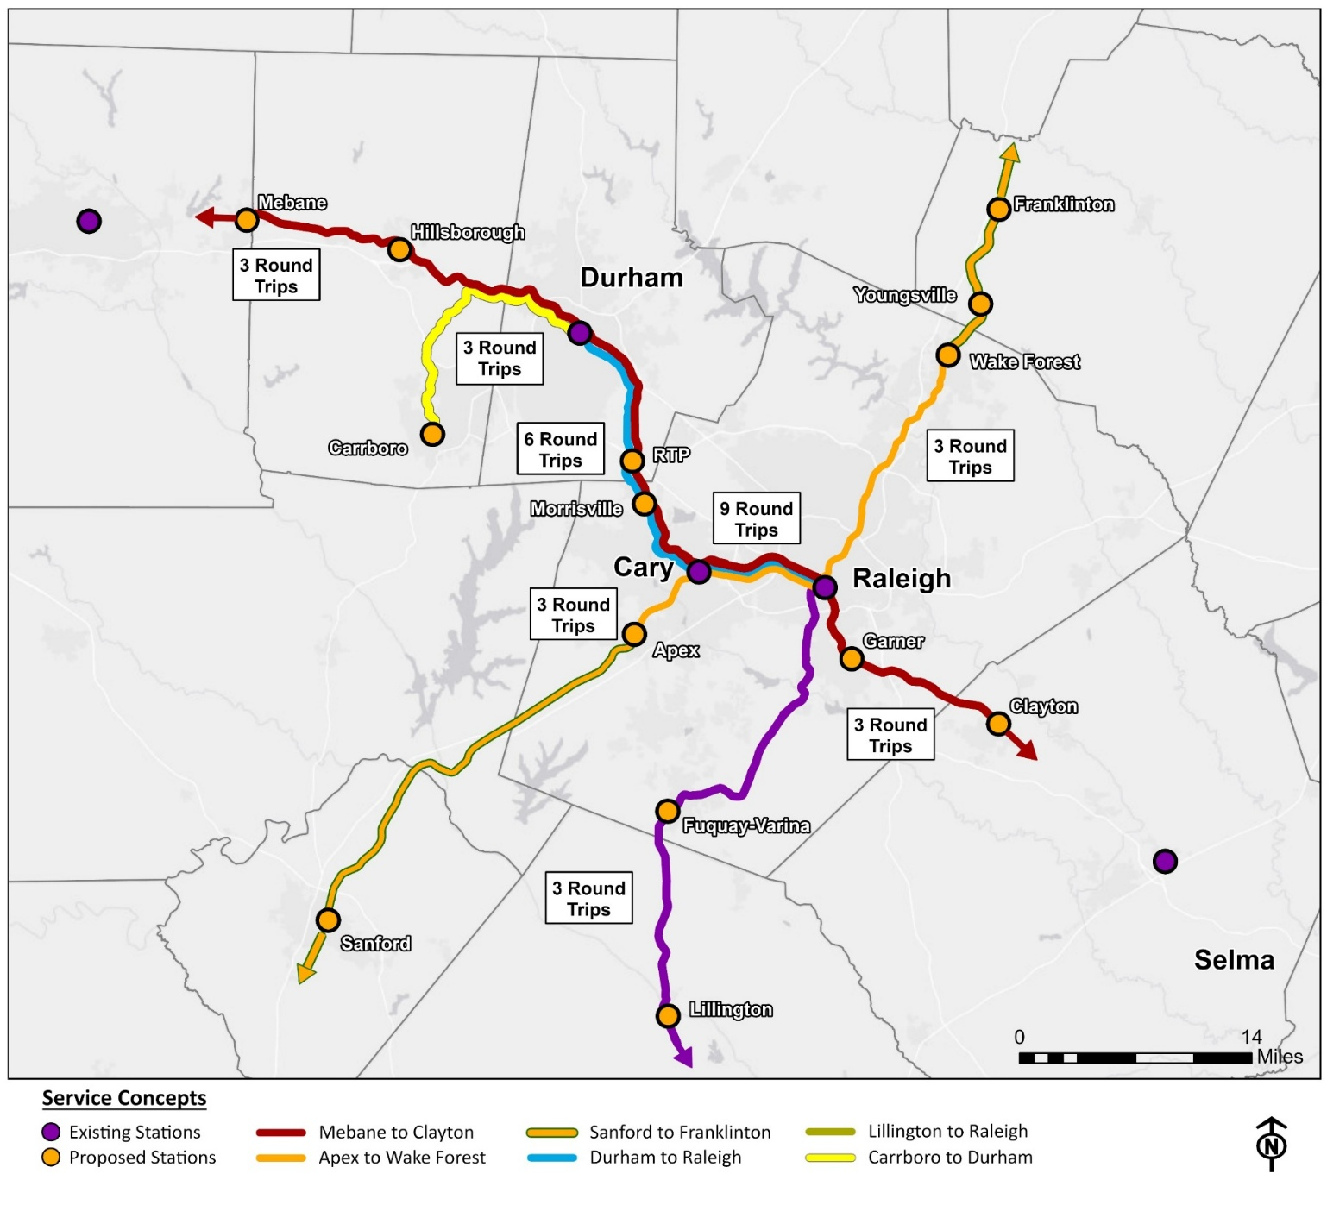

FUNDING IMPLICATIONS FOR DECISIONMAKING
Given the policy environment for rail investment described above, any framework for regional decision-making will need to contemplate a variety of capital cost contributions across various stakeholders. These could include:
- Projects in one MPO or Triangle County that benefit:
  - More than one Triangle County or MPO
  - Counties or MPOs outside of the core Triangle Counties and other adjacent MPO-member counties (Other MSAs such as Triad, Wilmington, Fayetteville, or even Charlotte)
- Projects that cross jurisdictional boundaries with the same potential combination of stakeholders as above
POTENTIAL COST-SHARING MODELS
In the Triangle, several ways of cost-sharing transit investments within the region have developed since Durham, Orange and Wake counties passed their ½-cent referenda in 2011, 2012, and 2016, respectively. Those include:
- 50:50 cost splits for express bus services with origins and destinations in 2 counties
- Splitting the cost of proposed commuter rail improvements by track miles in each county
- Allocating costs to regional transit hubs by ratios of population among the 3 counties
The nature of the FRA Worldview in Principle 1 suggests that Triangle stakeholders should develop expectations that they can communicate to potential funding partners in other cities, counties and metro regions across North Carolina.
POTENTIAL PRIORITIZATION MODELS
Within the decision-making framework, the Triangle region should focus less on the total number of potential users of any future passenger rail investment, and more on the number of factors that align with the likelihood of a project progressing to completion. A simple project screening checklist might include questions like:
- Is this project part of a Corridor ID grant received by NCDOT?
- Is this project on a rail line with an active operating passenger rail agreement with the host railroad? If not, is the host railroad interested in developing one?
- Does this project connect two Metropolitan Statistical Areas, or at least one Micropolitan Statistical Area to the Triangle?
- Does this project connect to any other existing intercity passenger rail service?
- Are there “low-hanging fruit” projects that would be strong candidates for state funding?
- Is this a passenger station or other project for new service that is unlikely to receive state funding, but could be a strategic investment with local dollars to accelerate the activation of new service?

