Executive Summary

BACKGROUND
In 2025, the Capital Area Metropolitan Planning Organization (CAMPO) and the Triangle West Transportation Planning Organization (TWTPO) commissioned HDR to complete the Triangle Rail study to develop a strategic approach for incremental expansion of Intercity Passenger Rail within the greater metropolitan area of the Research Triangle Region in North Carolina.
POTENTIAL SERVICE CONCEPTS
Several Service Concepts were proposed for the region. Each Service Concept identifies two endpoints for the rail service and assumptions about a service pattern. For each Service Concept in this study, we assumed 3 trains per day in each direction.
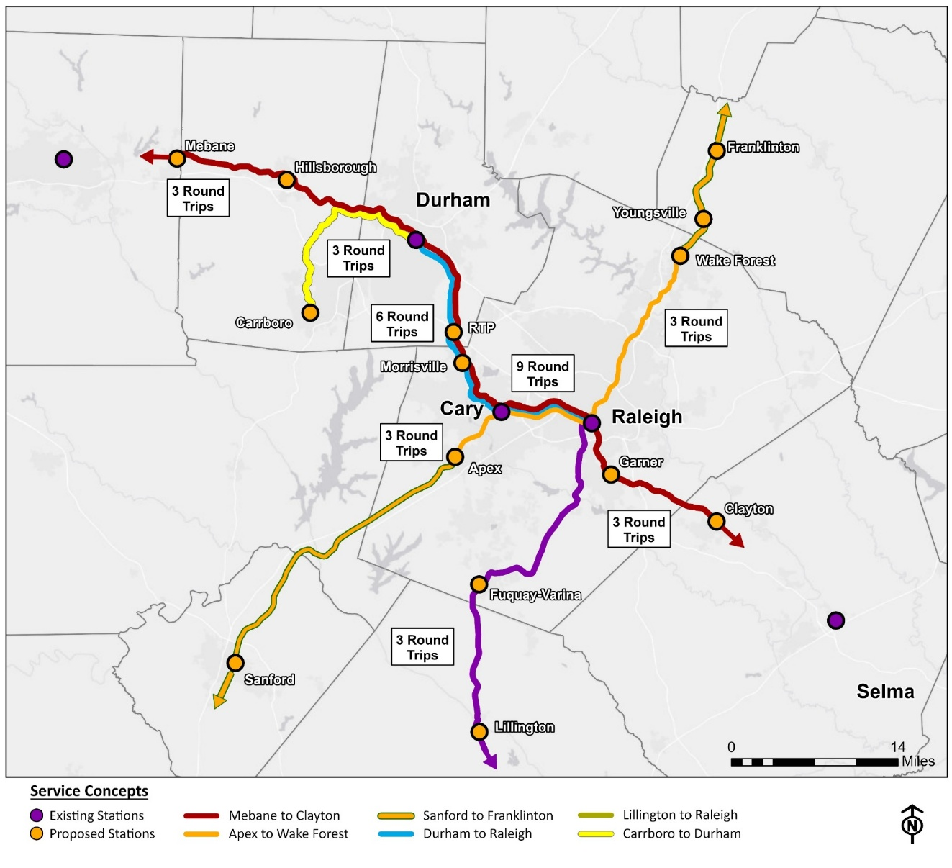
IDENTIFYING CAPITAL PROJECTS WITHIN SERVICE CONCEPTS
For each service concept, rail engineering experts proposed a series of track, signal, station and other Projects that would be needed to make the theoretical Service Concept possible. Some examples of typical Projects are shown below.
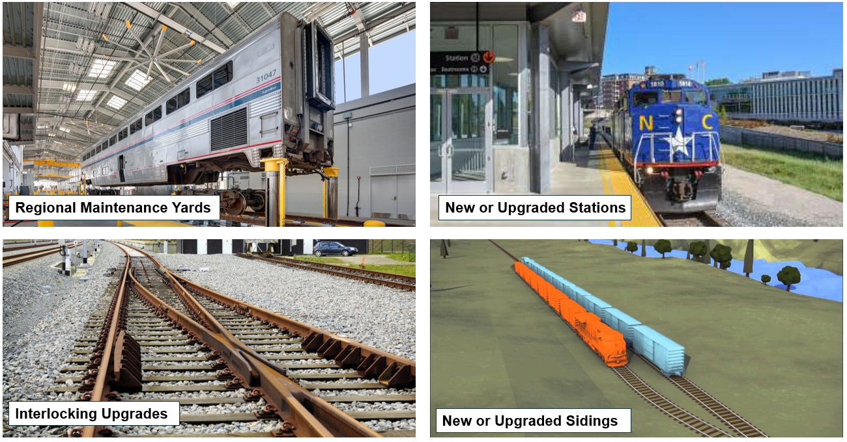
PROJECT MATRIX EVALUATING THE ABILITY TO ATTRACT FEDERAL AND STATE FUNDING
Each Service Concept was evaluated holistically for how attractive the Service Concept would be to Federal and State funding criteria for passenger rail investment and also for freight rail programs that fund investments that are beneficial to both freight and passenger rail.
The same evaluation approach was then applied to the individual Projects in each of the Service Concepts. This allows Triangle stakeholders to understand which individual Projects may be able to be recombined into other Service Concepts to attract funding, and which Projects may be best to pay for with local funds because their project characteristics are not well-tuned to Federal and State funding criteria.
A detailed Project Matrix spreadsheet contains key Project attributes and a rating of the relative attractiveness of each Project to Federal and State funding criteria as of June 2025.

A DECISION TREE FOR STRATEGIC INVESTMENT
While the largest investments in a Triangle Rail network are likely to be made through co-investment with Federal and State partners, there may be times when the region invests in the Triangle Rail network separate from these programs. In these situations, the following priority order for investments will allow for incremental progress while bigger programmatic investments are pursued.
- Grade Crossing Eliminations
- Advancing Station Work, including NEPA and Engineering studies
- Protective Land Purchases for a Regional Maintenance Facility and layover yards
- Interlockings and Sidings
- Ridership studies to prioritize which parts of long corridors to invest in first
- Investments in the NC-Line from Burlington to Selma
A DECISION-MAKING FRAMEWORK FOR STAKEHOLDER COLLABORATION
Developing the Triangle Rail network will take coordination among numerous stakeholders, all of which have their own priorities and different ways of looking at a rail network. Understanding the viewpoints of FRA, Federal Funding grant programs, freight railroads, NCDOT’s state funding programs, and NCDOT Rail’s goals and objectives – is crucial to balancing interests and finding paths to project delivery.
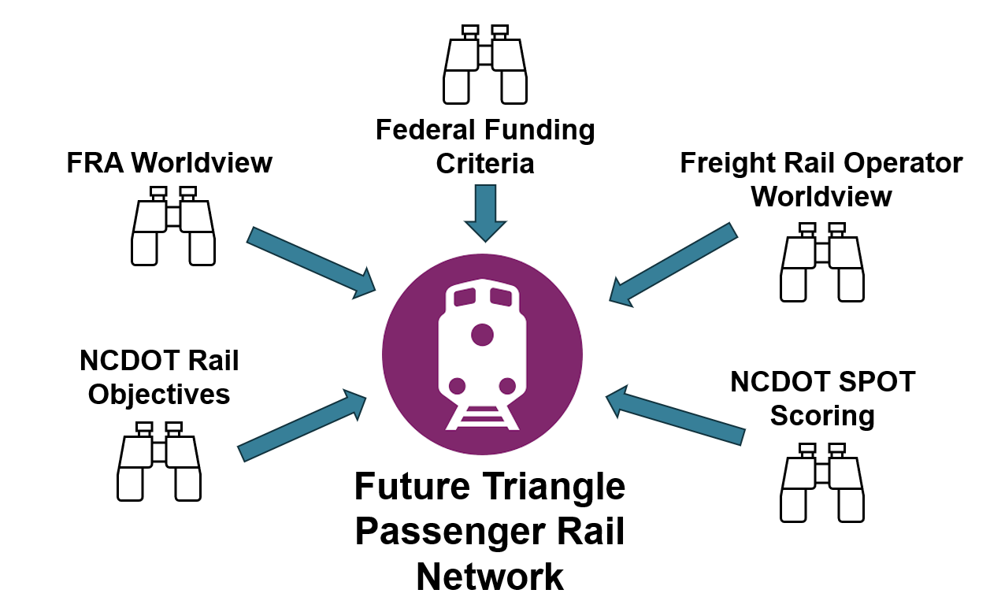
FUTURE STUDIES AND NEXT STEPS
Next steps beyond this study will include future studies that address ridership, network rail operations, and the potential to merge regional projects with state level Corridor ID rail development efforts.
Establishing a State & Triangle Region Rail Network Implementation work group that meets two to four times each year will allow the MPOs to prepare for SPOT submissions and rail priorities in their MTPs.

