Triangle West Transportation Planning Organization

2025 Language Access Plan

EXPLAINING THIS DRAFT DOCUMENT

* This document is drafted in plain language and adheres to the Plain Language Guidelines published by the [U.S. Department of Interior.](https://www.doi.gov/plainlanguage)
* Most of this document was drafted prior to the release of the following Executive Orders:
  + EO 14224: Designating English as the Official Language of The United States (revokes EO 13166)

**TPO Staff are monitoring federal changes and will edit this document as necessary**.

* This document does not contain any final figures, tables and/or images. Final images will be included within the final draft prior to adoption.

INTRODUCTION 4

BACKGROUND 5

Legal Framework 5

Table 1 5

ASSESSING LOCAL NEEDS 6

Four Factor Analysis for Triangle West 7

Factor 1: The number or proportion of LEP persons in the eligible service area 7

Factor 2: The frequency in which LEP persons encounter Triangle West programs 7

Item 1 8

Factor 3: The importance of the services provided by the Triangle West programs 8

Factor 4: The resources available and overall costs to Triangle West 10

MEETING THE NEEDS 11

Language Assistance 11

Providing Notice to LEP Persons 11

Training for Triangle West 12

Safe Harbor Stipulation (Continued from Factor 1) 12

APPENDIX – TPO Internal Policies for Translation and Interpretation (Language Assistance Continued) 14

Training Resources for Triangle West (Continued) 16

Data Utilized (From Table C16001) 17

Item A 17

Item B 17

# INTRODUCTION

Triangle West Transportation Planning Organization (Triangle West TPO) was established in 1980 as the Durham-Chapel Hill-Carrboro Metropolitan Planning Organization (DCHC MPO). This was required by the Federal Aid Highway Act of 1962, which made these organizations a necessity in urbanized areas with populations of over 50,000 people. These organizations operate with the goal of providing comprehensive and continuing transportation planning in their regions. This comprehensive and continuing transportation planning must occur in cooperation with state and local governments in the region. Through this cooperation, the TPO also has the goal of representing their partner governments and helping them advocate for funding and approval of their desired projects.

In 2025, the DCHC MPO changed its name to Triangle West TPO. This new name better reflects the variety of constituencies represented, which has expanded since 1980. Triangle West TPO is responsible for regional transportation planning for the western part of the Research Triangle in North Carolina including:

* City of Durham
* Town of Hillsborough
* Town of Chapel Hill
* Town of Carrboro
* Orange County
* Chatham County
* Durham County

In 2000, Executive Order 13166: Improving Access to Service for Persons with Limited English Proficiency was issued. This executive order required metropolitan planning organizations, including Triangle West TPO, to provide meaningful access for people with limited English proficiency to plans and programs offered by the TPO. In the past, the TPO has adopted Limited English Proficiency (LEP) Plans to adhere to the executive order 13166.

# BACKGROUND

The previous LEP plan was adopted by Triangle West TPO in February of 2021, adhering to the Department of Justice’s Limited English Proficiency Guidance issued in 2002. The 2021 LEP Plan detailed the following:

* A person who is considered LEP is someone who does not speak English as their primary language and does not fluently speak, read, or write English.
* Increased access to Spanish-speaking people was required based on the population of Spanish-speaking people.

## Legal Framework

The broader legal framework that outlines the components of Limited English Proficiency Plans is represented in Table 1. These will be used as the foundation of this Language Access Plan (LAP). The Language Access Plan will expand where necessary to more effectively meet the needs of Triangle West’s community.

### Table 1

|  |  |
| --- | --- |
| Federal Regulations | Relation to the Plan |
| Title VI of the Civil Rights Act of 1964 | Prohibits MPOs from discriminating on the grounds of race, color, or national origin (including language). Title VI requires all people to have fair access to participate in MPO’s planning processes. |
| Executive Order 13166 (2000) | Requires that MPOs provide meaningful access to people with LEP |
| Department of Justice LEP Guidance (2002) | Provides guidance to MPOs on how to comply with Title VI and EO 13166 and established the “four-factor” test. |
| Executive Order 14224 (2025) | Designated English as the official language of the United States. |
| Rescission of DOJ LEP Guidance (2025) | Rescinded the Department of Justice LEP Guidance of 2002. |

In 2000, Executive Order 13166 was signed into effect. This required agencies receiving federal funding to create Limited English Proficiency Plans. The order was followed by guidance from the Department of Justice, which recognized language discrimination as a form of national origin discrimination. Protection from national origin discrimination, including language discrimination, is based on Title VI of the Civil Rights Act of 1964.

Executive Order 13166 was rescinded in March of 2025 by Executive Order 14224. This was followed by a recission of DOJ guidance as well. At the time of the adoption of this plan, no additional guidance has been published by the Department of Justice.

# ASSESSING LOCAL NEEDS

To assess the need for language assistance and/or translation services within the Triangle West community, Triangle West uses the Four Factor Analysis. The Four Factor Analysis is an approved method used by the Department of Justice and Department of Transportation to assess the need for LEP services and policies to meet those needs. This analysis will move beyond LEP in Factors 3 and 4 to ensure that people with disabilities are also covered and protected by Triangle West policies.

## Four Factor Analysis for Triangle West

### Factor 1: The number or proportion of LEP persons in the eligible service area

According to data analysis based on the 2023 American Community Survey (ACS), the Triangle West region has two languages that fall under Safe Harbor protections: Spanish and Chinese (including Mandarin and Cantonese). Safe Harbor is a threshold set by the U.S. Department of Transportation clarifying which groups must be included in Limited English Proficiency plans and what constitutes compliance with federal guidelines. There are around 20,000 Spanish speaking people who are considered Limited English Proficiency and around 3,000 Chinese speaking people who are considered LEP. This surpasses the Safe Harbor threshold of 5% or 1,000 people, whichever is less, set by the U.S. Department of Transportation. As a result, the following requirements and policies will be set up to protect the language access of people who speak these languages.

Triangle West TPO recognizes that its municipal partners also have Language Access Plans based on their collected data from their communities. In as much as is feasible, Triangle West will attempt to accommodate these additional languages, especially in cases of community outreach in partner jurisdictions.

### Factor 2: The frequency in which LEP persons encounter Triangle West programs

Based on the statistics produced by ACS data analysis, Spanish speakers are the demographic most likely to interact with TPO staff. As a result, the TPO should be prepared to accommodate and respond to requests from Spanish speakers in the Triangle West area. Additionally, given the significant population of Chinese speakers, Triangle West will also prepare to accommodate requests from Chinese speakers. Triangle West also recognizes the population of people within its boundaries that have disabilities. As a result, the policies established by this document will include both people of limited English proficiency as well as people with vision and hearing impairments that impact communication.

TPO staff were surveyed internally to gauge the frequency of language assistance requests since the last LEP plan was adopted in 2021. The survey asked staff if they had had any language assistance requests since 2021, if they felt that “I Speak” cards would be helpful in the future, the frequency with which they received language assistance requests, and the languages that assistance was requested for. Feedback from staff signaled that “I Speak” Cards would be helpful, and language assistance was likely needed for Spanish and Mandarin/Chinese. An example of one of these that could be used by the TPO is below as Item 1. In the future, Triangle West should use surveys like these periodically to assess the demand for language assistance and gauge success providing language access to LEP and disabled individuals.

### Item 1

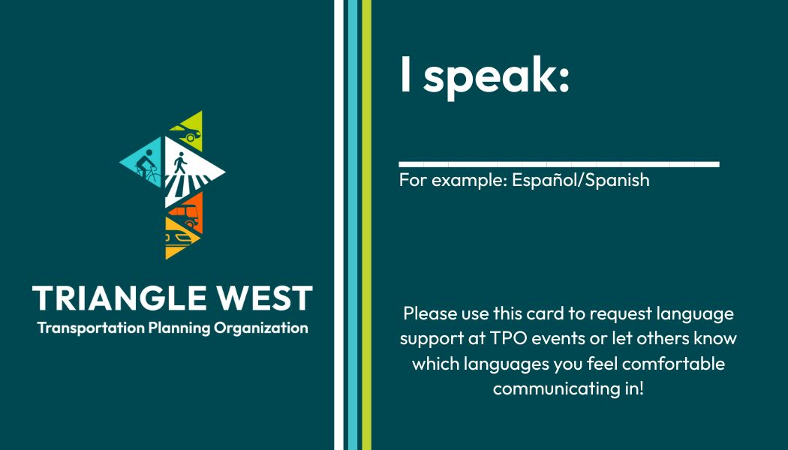

### Factor 3: The importance of the services provided by the Triangle West programs

Triangle West TPO provides a number of crucial services that engage directly with residents in TPO boundaries as well as support the work of partner jurisdictions. The TPO focuses on both short- and long-term transportation planning across the region. The Triangle West region is highly interconnected with a significant number of commuters who travel across city and county boundaries every day. Some of this work touches communities that have historically not been able to participate in the engagement and planning process. Ensuring that all communities in the region have access to the planning and engagement process is a crucial part of several plans that receive federal funding, including: the Unified Planning Work Program (UPWP), the ten-year Transportation Improvement Program (TIP), and the long-range Metropolitan Transportation Plan (MTP).

Additionally, the following documents are of “vital” importance to the work of the TPO:

* Metropolitan Transportation Plan
* Transportation Improvement Plan
* Unified Planning Work Plan
* Public Participation Plan

In seeking to ensure that there is an open and inclusive engagement process, the TPO will prepare summaries of these plans in Spanish and Chinese and will provide a copy in braille upon request. Summaries will more effectively meet resident needs, especially when these documents may be over a hundred pages in length. They will still provide the crucial information needed to understand the nature of the TPO’s work and help residents engage with the TPO.

The impacts of transportation projects affect everyone. As a result, it is important that all residents, regardless of language or disability status, are able to participate in planning for transportation projects. In such an interconnected region, decisions about transportation policies, programs and projects have ripple effects with economic impacts that extend beyond city limits. Having input from as many people as possible when planning decisions are made will ensure that everyone has access to economic opportunities across the Triangle West region and even beyond in neighboring urban areas, such as Raleigh and Burlington. This is also important because including people who historically have not been able to participate means that more people will be able to utilize their spending power to promote economic development in the region.

In addition to meeting the TPO’s MTP goal of stimulating inclusive economic vitality, a Language Access Plan helps meet many of the other goals of the MTP. By ensuring that all Triangle West residents can participate in the planning process, there will be more information on how to successfully connect people with places. This information and connection with residents will also enable the TPO to more effectively plan for multimodal and affordable transportation choices. Residents ultimately provide information that data cannot: the experience of day-to-day travel and commuting. Without this experiential feedback, TPO efforts will be limited to sources which cannot include vital information about the experience of travel. Language Access isn’t just about economic development but also about making sure that the TPO can produce the research necessary to serve resident needs as effectively as possible. With this high-quality research, the TPO can more effectively meet the goals of the MTP and the needs of local residents.

In addition to collaborating with local partners on transportation planning efforts, the TPO also collaborates extensively with NCDOT. NCDOT has its own process for assessing and guaranteeing inclusion of all residents in the transportation planning process.

### Factor 4: The resources available and overall costs to Triangle West

While it is likely that full translations of vital documents from English to Spanish or braille may represent an undue cost burden to the TPO, especially in the case of longer documents, the TPO can provide summaries in other languages to share key information. The option can be made available to translate full documents by request. These summaries should focus on the vital documents listed in the background section of this report.

Triangle West should also build relationships and partnerships with key organizations in the community that work directly with Spanish and Chinese-speaking people, as well as people with disabilities. This is a crucial step to ensure that all community members have the chance to participate and provide feedback to the TPO. Additionally, these organizations are likely to already provide translation and interpretation services.

# MEETING THE NEEDS

## Language Assistance

Language assistance involves a variety of methods to make information accessible to someone in the language they feel most comfortable communicating in, whether that be Chinese, Spanish or American Sign Language (ASL). Triangle West should make language assistance available in, at minimum, Chinese, Spanish, Braille, and provide ASL interpreters at certain community engagement events. The TPO should consider the Language Access Plans of partner jurisdictions when planning events in those areas to build trust and aid in gathering the information needed.

Language assistance will be available through the following:

* Triangle West TPO website via translation technology
* At community events upon request prior to the event
* Large print materials and braille upon request

## Providing Notice to LEP Persons

Notice should be given ahead of community engagement activities that language assistance is available along with the languages for which assistance will be made available. The TPO is not able to offer these services on-demand for all meetings and events, therefore language assistance must be requested ahead of time. The notice for requesting language services will be advertised clearly on social media and via flyers posted in key public places, especially public places likely to be frequented by community members who may need language assistance. Advertisements should include the email of a staff member who will be oversee arranging the necessary language assistance for the event or meeting.

Another strategy for providing notice is by word of mouth; through Focus Groups or Advisory Committees, Triangle West can connect with communities who may need language access and allow members to spread the word to each other. This can also include working with community organizations as partners to aid with this distribution.

## Training for Triangle West

Triangle West will also implement the following to better prepare TPO staff for interactions with people of limited English proficiency:

* Cultural Sensitivity and Awareness Trainings
* Basic Language Trainings
* Use of Plain Language and Visual Aids
* Hiring of Professional Interpreters and Translators
* Leveraging Translation Technology and Devices

Training of TPO staff should occur at least once a year.

## Safe Harbor Stipulation (Continued from Factor 1)

The Safe Habor stipulation is a policy benchmark for deciding which languages are entitled to protections in LEP plans. The threshold is either 5% of the population or 1,000 people, whichever is less. This threshold is established to provide a guideline for providing written translations that will create a “safe harbor” for individuals considered to be limited in English proficiency. Safe Harbor does not apply to providing oral interpreters or other forms of language access. Compliance with language assistance for languages that meet this threshold will be utilized as evidence of compliance with federal guidelines.

Triangle West’s goal is to prioritize language access based on established need. There is a significant portion of the community that is Spanish and Chinese speaking and considered to be limited in English proficiency. Triangle West will consider the language needs of community members based on the Language Access Plans and/or Limited English Proficiency Plans of member jurisdictions, such as the Town of Chapel Hill and Town of Carrboro. Utilizing these plans will allow Triangle West to more efficiently leverage language resources by targeting them to the specific communities where they are most needed. This approach is more tailored to the needs of communities in Triangle West’s boundaries and reduces translation costs while still meeting Safe Harbor requirements.

# APPENDIX – TPO Internal Policies for Translation and Interpretation (Language Assistance Continued)

Where possible, the TPO should invest in professional translations from providers with an educational background in translation. Bilingual employees may assist in proofreading these translations and ensuring that the translations meet the TPO’s needs. However, unless the TPO employee has an educational background in translation or is otherwise certified to provide professional translation services, their role should be largely supportive.

As of the writing of this plan in 2025, the cost of translation from English to Spanish typically ranges from 15 to 25 cents a word. However, depending on the type of document, costs may increase if a more specialized translator with more technical knowledge is needed. The cost for braille translations is similar. The website and other translations produced by technology should be reviewed by humans with advanced language skills, where possible. Additionally, the website should also receive a thorough vetting process on its accessibility for low-vision individuals, compatibility with screen readers, and whether it works with mobile devices.

Additionally, the TPO should consider investing in professional translation for the website instead of relying on machine translation, or AI translation, which is often inadequate or inaccurate. Here, bilingual TPO employees may assist with translation. However, since the website is the primary source of information for residents, paying for professional translation would be a sound investment in ensuring that residents with different needs have access to accurate information. There are several companies that provide professional translation in a variety of languages. These companies will be vetted by Triangle West before being offered a contract to provide translation services.

For services for people with disabilities, Triangle West will work with the North Carolina Department of Health and Human Services for workshops on communicating with people with vision and hearing impairments. NCDHHS also has ASL interpreters that can assist at community engagement events. Triangle West may also research and vet other providers of training on communication with people with disabilities, if the staff decides that additional training is needed. This should be supplemented by internal staff training and guides intended to ensure quick and easy access to information on communicating with residents who are LEP or disabled.

The TPO may also form relationships with community partners who work directly with communities that may benefit from translated documents, such as El Centro Hispano and Triangle Disability Awareness Council. These partnerships will enable more efficient distribution of translated materials and support rapport building between the TPO and community members. The TPO will take steps to identify other community partners who will support the goals of the Plan and ensure that the community engagement process is inclusive and accessible to all.

Triangle West may also implement the voluntary use of “I Speak” cards at community engagement events. These cards will enable community members to self-identify their fluency in another language. The cards will allow Triangle West to informally gauge the need for additional language materials and interpreters. However, these cards are not useful for those who have vision or hearing impairments, and another method is necessary to gauge those needs. A sign-in sheet with an entirely voluntary self-identification of disability may suffice until a more useful alternative is found.

## Training Resources for Triangle West (Continued)

A number of organizations in the region are able to provide training to staff, as deemed necessary.

* Durham Technical Community College offers both a [certificate](https://www.durhamtech.edu/programs-pathways/community-spanish-interpreter-public-service-certificate) and a [diploma](https://www.durhamtech.edu/programs-pathways/community-spanish-interpreter-public-service-diploma) to become a Community Spanish Interpreter, Public Service, which can be completed in as little 8 months or as many as 20 months. The timeline varies by type of certification.
* NC Central University also offers an online [Professional Interpretation](https://careertraining.nccu.edu/training-programs/professional-interpreter-course-online/) course, but this does not come with any official certifications.

These programs represent important additional steps in training employees to be able to more effectively provide language access and reduce reliance on outside organizations.

Trainings for communicating with disabled people or Chinese translation appear to be much more limited. However, the [National Federation of the Blind](https://nfb.org/programs-services/braille-certification) does provide a course for Braille Certification. The [National Instructional Materials Access](https://www.nimac.us/free-training-courses-for-braille-transcribers-working-with-nimas-files/) also provides information on being trained to transcribe educational materials to braille.

It is likely that trainings for braille, ASL, and Chinese will require more research, vetting, and relationship building than Spanish translation certifications.

## Data Utilized (From Table C16001)

### Item A

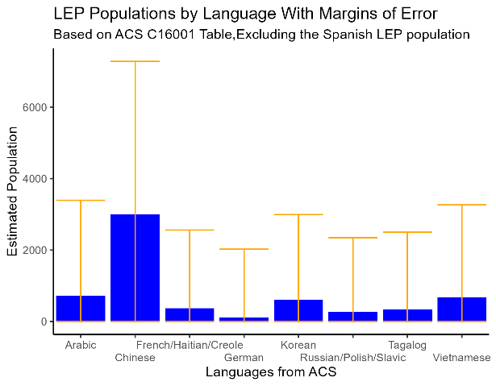

### Item B

